Mobile Wallet
# Source: AI Source: Provided by: [Data Path: Persons Table -> ID Column: 1, Name_En Column: Motasem Essam] -> From: [ChatGPT] on [1/21/2026]
A Mobile Wallet is a hot crypto wallet in the form of a mobile app that allows users to store, send, receive, and manage cryptocurrencies directly from a smartphone. It is designed for on-the-go access, combining convenience with core crypto functionality.

📱 Key Characteristics of Mobile Wallets:
# Source: AI Source: Provided by: [Data Path: Persons Table -> ID Column: 1, Name_En Column: Motasem Essam] -> From: [ChatGPT] on [1/21/2026]
- Mobile App-Based
  - Installed on iOS or Android devices via app stores.
  - Can be custodial (exchange-managed) or non-custodial (user holds keys).
- Private Key Storage
  - Stored locally on the mobile device (non-custodial) or on servers (custodial).
  - Often protected by device PIN, biometrics, or encryption.
- Multi-Functionality
  - Many wallets support crypto swaps, staking, NFTs, DApps, and Web3 access.
- QR Code Support
  - Easily send/receive crypto via QR code scanning.

👜 Examples of Mobile Wallets:
# Source: AI Source: Provided by: [Data Path: Persons Table -> ID Column: 1, Name_En Column: Motasem Essam] -> From: [ChatGPT] on [1/21/2026]
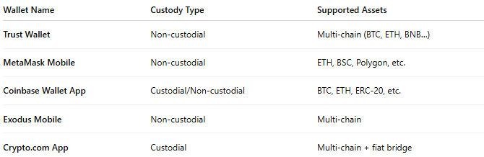

Wallet Name | Custody Type | Supported Assets
Trust Wallet | Non-custodial | Multi-chain (BTC, ETH, BNB…)
MetaMask Mobile | Non-custodial | ETH, BSC, Polygon, etc.
Coinbase Wallet App | Custodial/Non-custodial | BTC, ETH, ERC-20, etc.
Exodus Mobile | Non-custodial | Multi-chain
Crypto.com App | Custodial | Multi-chain + fiat bridge

🛠️ How It Works:
# Source: AI Source: Provided by: [Data Path: Persons Table -> ID Column: 1, Name_En Column: Motasem Essam] -> From: [ChatGPT] on [1/21/2026]
- User downloads and installs the wallet app.
- In non-custodial wallets, a seed phrase is generated and must be backed up.
- User can:
  - Store and manage multiple cryptocurrencies
  - Send/receive crypto via address or QR code
  - Use DApps, NFTs, and DeFi protocols (if supported)
- Transactions are signed on-device and broadcast to the blockchain.

✅ Advantages:
# Source: AI Source: Provided by: [Data Path: Persons Table -> ID Column: 1, Name_En Column: Motasem Essam] -> From: [ChatGPT] on [1/21/2026]
- Portable and user-friendly
- Enables fast payments from anywhere
- Integrated with QR codes and contact lists
- Many support Web3 and NFT features
- Often supports biometric security

⚠️ Disadvantages:
# Source: AI Source: Provided by: [Data Path: Persons Table -> ID Column: 1, Name_En Column: Motasem Essam] -> From: [ChatGPT] on [1/21/2026]
- Less secure than cold wallets (vulnerable to phone hacks, theft)
- Risk of losing funds if the phone is lost/stolen without backup
- Battery/power dependence for access
- May be limited in features compared to desktop or hardware wallets

🧠 Best Use Cases:
# Source: AI Source: Provided by: [Data Path: Persons Table -> ID Column: 1, Name_En Column: Motasem Essam] -> From: [ChatGPT] on [1/21/2026]
- Everyday crypto users
- Peer-to-peer payments and mobile-based DeFi/NFT access
- Small-to-medium crypto holdings
- Users participating in crypto rewards, airdrops, and staking

🆚 Mobile Wallet vs Other Wallet Types:
# Source: AI Source: Provided by: [Data Path: Persons Table -> ID Column: 1, Name_En Column: Motasem Essam] -> From: [ChatGPT] on [1/21/2026]
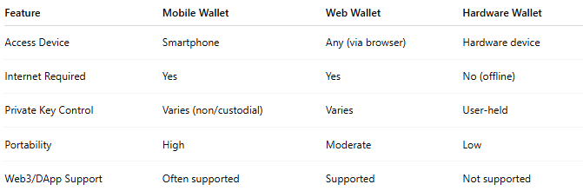

Feature | Mobile Wallet | Web Wallet | Hardware Wallet
Access Device | Smartphone | Any (via browser) | Hardware device
Internet Required | Yes | Yes | No (offline)
Private Key Control | Varies (non/custodial) | Varies | User-held
Portability | High | Moderate | Low
Web3/DApp Support | Often supported | Supported | Not supported

🔐 Security Tips for Mobile Wallets:
# Source: AI Source: Provided by: [Data Path: Persons Table -> ID Column: 1, Name_En Column: Motasem Essam] -> From: [ChatGPT] on [1/21/2026]
- Enable device PIN, biometric lock, and app password
- Back up your recovery phrase securely and offline
- Avoid using wallets on rooted or jailbroken devices
- Keep your wallet app updated from official app stores

